2nd Annual

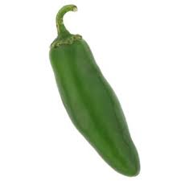

2nd Saturday of March Madness
Date: Sat., March 28th, 2020
Time: 1PM to 5PM
Location: E.P. Council #1528
3200 Pawtucket Ave.
Admission: $10 Per person
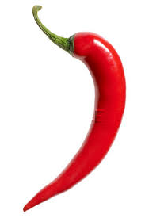
Children under 12 Free
Proceeds to benefit
R. I. Special Olympics

Vote for your favorite chili recipe.
Chili – Raffles – NCAA Basketball

